# Data Interpretation

## MIC Assay Result Analysis

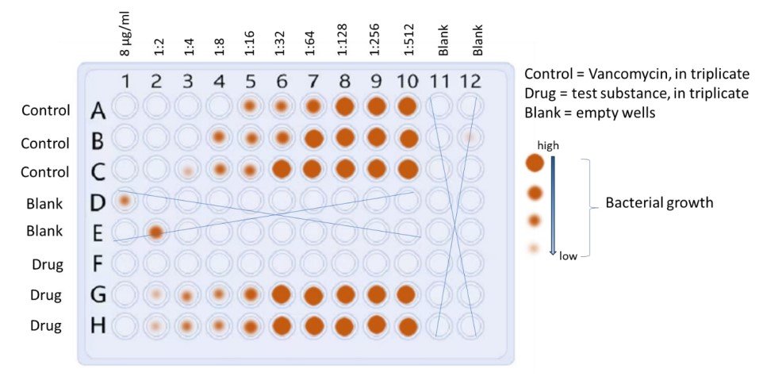

**Plate Layout and Observations:**

The image depicts a 96-well plate used in a Minimum Inhibitory Concentration (MIC) assay to assess the effectiveness of an antibiotic (Vancomycin) and a test drug against Staphylococcus aureus bacteria. Each well represents a specific concentration of the drug or control. Orange circles represent the observed size of bacterial pellets, indicating growth.

Rows D and E, and columns 11 and 12 are blank (marked with 'X'), likely serving as negative controls to ensure the absence of contamination. Each concentration of the control antibiotic and test drug was plated in triplicate (three wells) to account for potential variability.

**Interpretation:**

By analyzing the presence and size of the orange circles, we can infer the growth or inhibition of bacteria at different drug concentrations. In this specific image, it appears that Vancomycin (control antibiotic) effectively inhibits bacterial growth at all tested concentrations (no orange circles observed). This indicates that Vancomycin is potent against the S. aureus strain used in this assay.

**Inference and Next Steps:**

For the test drug, the presence and size of orange circles indicate varying degrees of bacterial growth inhibition. Further analysis is needed to determine the Minimum Inhibitory Concentration (MIC), which is the lowest concentration of the test drug that completely inhibits bacterial growth (no visible orange circles).

## Absorbance Measurement for Cell Toxicity Analysis

|  |  |  |
| --- | --- | --- |
| **Group** | **96-well position** | **Absorbance** |
| Control | B2 | 0.55 |
| Control | B3 | 0.8 |
| Control | B4 | 0.65 |
| Control | B5 | 0.6 |
| Control | B6 | 0.54 |
| Control | B7 | 0.4 |
| Treated | C2 | 0.35 |
| Treated | C3 | 0.4 |
| Treated | C4 | 0.24 |
| Treated | C5 | 0.5 |
| Treated | C6 | 0.4 |
| Treated | C7 | 0.35 |

## Descriptive Statistics

The absorbance values exhibit a central tendency with a mean of 0.481667, indicating the average level of cell toxicity across the samples. The median of 0.450000 suggests that the distribution is relatively symmetric. The standard deviation of 0.155261 signifies moderate variability around the mean, indicating that some samples deviate from the average absorbance. The range from the minimum of 0.240000 to the maximum of 0.800000 illustrates the spread of cell toxicity levels within the dataset. The interquartile range (IQR) between the 25th and 75th percentiles (0.387500 to 0.562500) capture the middle 50% of the data, highlighting the concentration of absorbance values. In the context of the case study, these descriptive statistics provide a quantitative understanding of the variability in cell toxicity across samples. The mean and median offer insights into the typical level of toxicity, while the standard deviation and range depict the degree of dispersion. Researchers can use this information to assess the consistency and range of cell toxicity responses, aiding in the interpretation of the drug compound's impact on cell viability.

## Comparison of Control and Treatment Groups

The comparison of mean absorbance values between the control and treatment groups reveals a notable difference. The control group exhibits a higher mean absorbance of 0.590000 compared to the treatment group, which has a lower mean absorbance of 0.373333. In the context of cell toxicity assays, a lower absorbance is often associated with reduced cell viability. Therefore, the lower mean absorbance in the treatment group suggests a potential protective effect of the novel bioactive compound against cell toxicity. This finding implies that the drug may have anti-toxic properties or, conversely, could be less harmful to cells compared to the control group. While further statistical analyses would be needed to establish the significance of this difference, this initial observation indicates a promising direction for the study. It suggests that the novel bioactive compound might have a positive impact on cell viability, supporting its potential application in mitigating toxicity, a crucial aspect in drug development and safety assessment.

Top of Form

## Relative Cell Toxicity Analysis

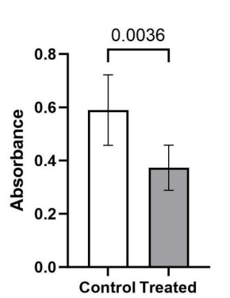

**Analysis of Cell Toxicity Test Results:**

The provided information and image depict the results of an in vitro cell toxicity test using the Human Embryonic Kidney cell line (HEK293T). The experiment compared the relative toxicity of a substance (treatment) to untreated control cells.

**Observations:**

The image shows a bar graph where the white bars represent the mean relative absorbance (a measure of cell viability) for untreated control cells, and the grey bars represent the mean relative absorbance for treated cells. Error bars indicate the standard deviation (SD) around the mean values.

A key finding is the statistically significant difference (p-value = 0.0036) between the control and treated groups, as calculated using a one-tailed Student's t-test. This p-value, well below the commonly accepted threshold of 0.05, indicates that the observed difference is unlikely due to chance and suggests a **true effect of the treatment on cell viability**.

**Interpretation and Inference:**

Based on the lower mean absorbance in the treated group compared to the control, we can infer that the tested substance **reduces the viability of HEK293T cells**. The statistically significant difference further strengthens this conclusion, suggesting a **potent cytotoxic effect**.

# Experimental Design Critique and Improvement Plan

## Weakness in the Experimental Setup

1. **Limited Diversity in Bacterial Strain:**
   * The MIC assay focuses solely on the antimicrobial effects against Staphylococcus aureus. To enhance the applicability of the findings, it would be beneficial to include multiple bacterial strains, reflecting different resistance profiles. This broader approach could provide a more comprehensive understanding of the compound's antimicrobial spectrum.

The use of the MIC assay to assess antimicrobial effects against a single bacterial strain, such as Staphylococcus aureus, is a significant weakness in experimental design. This approach overlooks the potential for interlaboratory variability, which can significantly impact the accuracy of susceptibility classification (Annis, 2005). Furthermore, the MIC alone may not adequately capture the complex relationship between antimicrobial concentration, bacterial susceptibility, and pharmacodynamic response (Wen, 2016). The assay's inability to account for the heterogeneity of bacterial populations further limits its applicability (Scavizzi, 2002). Finally, in vitro testing systems, including the MIC assay, do not fully replicate the host environment, leading to discrepancies between in vitro susceptibility tests and in vivo results (Nightingale, 1987). Therefore, the inclusion of multiple bacterial strains with different resistance profiles is crucial to enhance the applicability of findings and provide a more comprehensive understanding of the compound's antimicrobial spectrum.

1. **Single Concentration for Cell Toxicity Test:**
   * The cell toxicity test utilizes only one concentration (16μg/ml) of the antimicrobial compound. A broader range of concentrations should be tested to establish a dose-response relationship and determine the threshold concentration at which toxicity becomes significant. This additional information is crucial for evaluating the safety profile of the compound.

The use of a single concentration in cell toxicity testing, as highlighted by the query, is a significant weakness in the experiment. This approach fails to establish a dose-response relationship, which is crucial for determining the threshold concentration at which toxicity becomes significant (Ryan, 2011). Furthermore, it overlooks the potential for complex deviation patterns, such as dose level-dependent effects, which can be detected through multiple dose-response analysis (Jonker, 2005). The assumption of constant compound concentration in the analysis of bioassays, as discussed by Péry (2001), further underscores the need for a broader range of concentrations to be tested to accurately evaluate the safety profile of the antimicrobial compound.

1. **Use of DMSO as a Solvent:**
   * The antimicrobial compound is dissolved in DMSO for the cell toxicity test. Since DMSO can have its own impact on cell viability, it's essential to include a control group with DMSO alone to distinguish the potential toxic effects of the solvent from those of the antimicrobial compound.

The use of DMSO as a solvent in cell toxicity tests can be a significant weakness, as it can have its own impact on cell viability. Studies have shown that DMSO can inactivate certain compounds, such as platinum complexes (Hall, 2014), and modulate the toxicity patterns of hydrophobic organic compounds (Modrzyński, 2019). It can also induce behavioural abnormalities in aquatic species (Huang, 2018) and affect the antibiotic sensitivity of medically important microorganisms (Pottz, 1967). Therefore, it is crucial to include a control group with DMSO alone to distinguish its potential toxic effects from those of the antimicrobial compound.

**Weakness in Data Analysis:**

1. **Limited Statistical Analysis for MIC Assay:**
   * The MIC assay results are presented schematically in Figure 2, but there's no mention of statistical analysis for this assay. Including statistical tests, such as determining the significance of differences between control and test groups, would strengthen the reliability of the antimicrobial efficacy results.

The lack of statistical analysis in the MIC assay results, as highlighted in Figure 2, is a significant weakness in the data analysis of the experiment. This is supported by Annis (2005), who emphasizes the impact of laboratory-to-laboratory variability on the reliability of MIC results. Gehring (2013) further underscores the limitations of MIC as the sole criterion in antimicrobial drug dosage regimen design, emphasizing the need for a more comprehensive approach. Holstein (2015) and Schwarz (2010) both stress the importance of robust statistical methods and the avoidance of recurring errors in antimicrobial susceptibility testing, respectively. Therefore, the absence of statistical analysis in the MIC assay results undermines the reliability and validity of the antimicrobial efficacy findings.

**Proposed Plan for Improved Experimental Design:**

1. **Diverse Bacterial Strain Selection:**
   * Include multiple bacterial strains with varying resistance profiles in the MIC assay. This expanded approach will provide a more comprehensive understanding of the compound's antimicrobial spectrum. Different strains, such as Gram-negative and other Gram-positive bacteria, should be chosen to better reflect real-world scenarios and improve the generalizability of the findings.

Including multiple bacterial strains with varying resistance profiles in the Minimum Inhibitory Concentration (MIC) assay, as recommended by the proposed plan, can significantly enhance the results of the experiment. This approach aligns with the findings of Card (2012), who demonstrated the correlation between microarray-positive results and antimicrobial resistance phenotypes in Gram-negative bacteria. The study by Veloo (2019) further supports this, highlighting the extensive differences in antimicrobial susceptibility profiles among anaerobic bacteria in different countries. Danquah (2022) underscores the importance of exploring diverse microbial sources for antimicrobial compounds, which can be reflected in the selection of bacterial strains. However, it is crucial to consider the potential impact of interlaboratory variability on antimicrobial susceptibility determination, as highlighted by Annis (2005), and to address this in the experimental design.

1. **Dose-Response Relationship in Cell Toxicity Test:**
   * Conduct the cell toxicity test with a broader range of concentrations, including multiple dilutions of the antimicrobial compound. This will allow for the establishment of a dose-response relationship, aiding in the determination of the threshold concentration at which toxicity becomes significant. Testing a range of concentrations is crucial for accurately evaluating the safety profile of the compound and identifying potential concentration-dependent effects.

A broader range of concentrations in a cell toxicity test, as recommended by the proposed plan, is crucial for accurately evaluating the safety profile of an antimicrobial compound (Tsatsakis, 2016). This approach allows for the establishment of a dose-response relationship, aiding in the determination of the threshold concentration at which toxicity becomes significant (Ruberg, 1995). It also enables the identification of potential concentration-dependent effects, which is essential for understanding the compound's impact on cells (Tukey, 1985). However, it is important to carefully plan the layout of treatments in the assay to increase precision and remove the effect of systematic variation (Brown, 1976).

1. **Control Group with DMSO Alone:**
   * In the cell toxicity test, include a control group treated with DMSO alone to distinguish the potential toxic effects of the solvent from those of the antimicrobial compound. This additional control will help isolate any impact of DMSO on cell viability, providing a clearer interpretation of the compound's toxicity independent of the solvent.

The inclusion of a control group treated with DMSO alone in an experiment on the antimicrobial effect and cell toxicity is crucial for isolating the impact of the solvent on cell viability. Brayton (1986) highlights DMSO's strong affinity for water and its potential to enhance the penetration of other substances across biological membranes, underscoring the need to distinguish its effects from those of the antimicrobial compound. Violante (2002) further emphasizes the importance of evaluating the cytotoxicity of DMSO, as it can induce significant alterations in cell viability at certain concentrations. Rammler (1967) and Jacob (1986) provide a broader context, discussing DMSO's chemical properties and pharmacological actions, which can potentially influence cell toxicity. Therefore, the inclusion of a DMSO control group will enhance the experiment's results by providing a clearer interpretation of the compound's toxicity independent of the solvent.

1. **Statistical Analysis for MIC Assay:**
   * Incorporate robust statistical analysis for the MIC assay results to determine the significance of differences between control and test groups. Employ appropriate statistical tests, such as the student’s t-test or ANOVA, to enhance the reliability and validity of the antimicrobial efficacy findings. This will ensure a more rigorous interpretation of the MIC results and strengthen the overall experimental conclusions.

Incorporating robust statistical analysis, such as the t-test and ANOVA, in the MIC assay can significantly enhance the reliability and validity of antimicrobial efficacy findings (Lorowitz, 2005). This is particularly important in the context of microarray experiments, where the lack of proper statistical understanding can lead to misinterpretation of results (Owzar, 2011). Furthermore, the use of quantitative MIC tests has been shown to improve the individualization of therapeutic regimens, potentially leading to enhanced clinical efficacy (Craig, 1993). Therefore, the inclusion of robust statistical analysis in the MIC assay can not only strengthen the experimental conclusions but also improve the potential for clinical application.